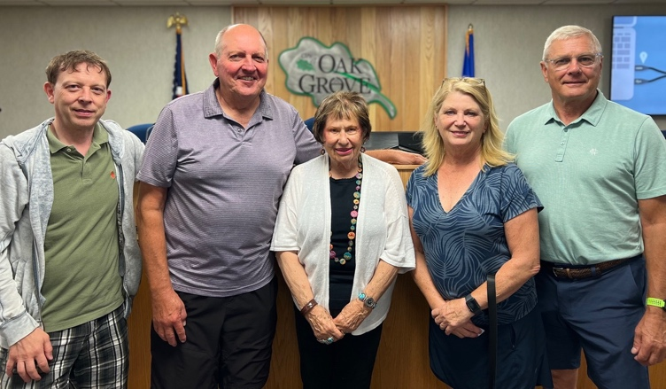

LGID officers: L-R Jay Edwardson, 2nd Vice Chair, Don Nast, 1st Vice Chair, Juanita Reed-Boniface, Chair, Robyn Erickson, Secretary, Pat Graiziger, Treasurer.

Lake George Improvement District Holds Annual Meeting

The 16th Annual Meeting of the Lake George Improvement District was held at Oak Grove City Hall August 19. Lakeshore owners attending the meeting enjoyed a pre-meeting social hour with ice cream treats courtesy of St. Francis Dairy Queen and music by Joel and Glenn Olson. Guests included Oak Grove Mayor Weston Rolf .

Ben Meyer, Wetland Specialist, Minnesota Board of Water and Soil Resources was guest speaker and led the audience through an understanding of what constitutes a wetland, classification of wetlands, frequency and duration of wetlands, how they are regulated and agencies who have oversight of wetlands.

During the business meeting annual reports were given by the chair and chairs of standing committees-By-laws, policies and procedures, Education, Communication Don Nast, and Financial Administration Pat Graiziger. Additional reports were given by Jaiden Edwardson, Lake Ecology Management Coordinator and John Vilandre, Administrative Coordinator.

New business action items included presentation of and vote on the budget for 2026, property assessment of $200 for 2026, and authorization of budget items that exceed $5,000. All passed. Robyn Erickson was the only candidate for the open position on the board, and received a unanimous vote. She will serve for a 3-year term.

Donald Banta was recognized as a dedicated and respected volunteer for his stalwart presence at the Lake George Boat Launch, assisting incoming and outgoing boats to follow established procedures to protect Lake George and other bodies of water from the spread of invasive aquatic plants and animals.